Directions for Shape Poem

Shape poems are made up of words that have been placed in such a way that they make the shape of an object and also use words to describe the object.

Step 1: Start by making a simple outline of the shape or object ( an animal, a football, a fruit etc.) large enough to fill a piece of paper.

Step 2: Then brainstorm a minimum of ten words and phrases that describe the shape. List action and feeling words as well.

Step 3: Next, place a piece of paper over the shape and decide where your words are going to be placed so that they outline your shape but also fit well together.

Step 4: Separate words and phrases with commas.

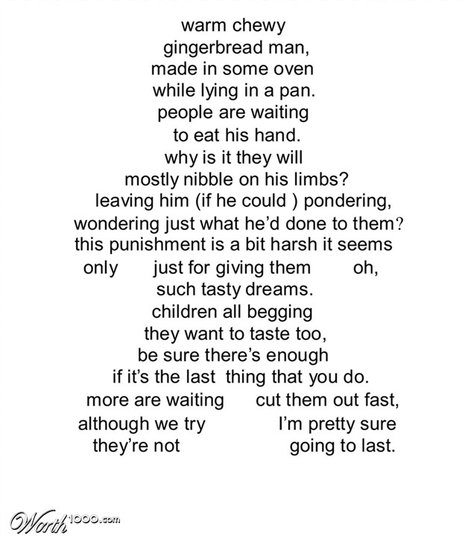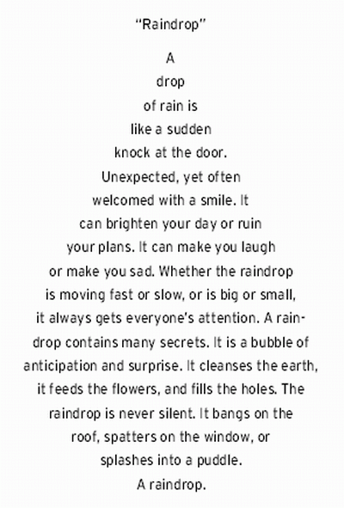

Shape Poem

One Word (Nouns/Adjectives) | Phrases

